

Faculty of Engineering and Computer Science

Department of Computer Science

**Introduction to Game Development**

**COMP3332**

Prepared by:

Dr. Sobhi Ahmad

Jumana Asad

Contents

Introduction to Game Design and 3D Modeling 8

Game Design 8

3D Graphics and Modeling 11

Blender 12

Game Development Using Unity 14

Scripts 35

Prefabs 37

Scripting – Instantiate 38

Scripts - Input 39

Raycating 41

Camera, Lights, Assets and Prefabs. 47

Camera 47

Lights 51

Prefabs 55

Layers 56

Terrains 57

Physics and UI 63

**Activities**

Activity 1: Game Analysis 11

Activity2: Comparison of 3D modeling and animation Tools 12

Activity 3: Blender – Object Mode 13

Activity 4: Multi-Colored Chair – Edit Mode 13

Activity5: Bishop (Using Spin) 13

Activity6: Animation 13

Activity 2.1: Cube Rotation – in Class 30

Activity 2.2: Discover Unity Interface and Object Manipulation. 30

Activity 2.3: Creating Simple Material 33

Activity 2.4: Applying Textures, Shaders, and Materials to Models 34

Activity 2.5: Solar System (Part 1) 35

Activity 2.5: Solar System (Addition) 35

Activity 3.1: Starting scripts 36

Activity 3.2: Script Transform 37

Activity 3.3: Create Prefabs 38

Activity 3.4: Instantiate function 39

Activity 4.1: Scripts – Keyboard Movement 40

Activity 4.2: Exercise – Input 41

Activity 4.3: RayCast 42

Activity 4.5: Mouse Movements 42

Activity 4.6: Mouse Movements - 2 43

Activity 4.7: Mouse Movement – 3 43

Activity 4.8: Touch Detection – 1 44

Activity 4.9: Touch Detection – 2 46

Activity 5.1.1: Working with Multiple Cameras 48

Activity 5.1.2: Creating a Split-Screen Camera System 48

Activity 5.1.3: Creating a Picture-in-Picture Effect 49

Activity 5.1.4: Exercise: 50

Activity 5.2.1: Adding a Point Light to a Scene 52

Activity 5.2.2: Adding a Spotlight to a Scene 52

Activity 5.2.3: Adding a Directional Light to a Scene 53

Activity 5.2.4: Area Lights and Emissive Materials: Creating Lights Out of Objects 53

Activity 5.2.5: Halos (send to moodle) 53

Activity 5.2.6: Adding a Cookie to a Spotlight (Send To Moodle) 54

Activity 5.3.1: Prefabs 56

Activity 5.4.1: Layers 57

Activity 5.5.1: Creating a Terrain 58

Activity 5.5.2: Terrain Continued (FBC and Web version) 63

Activity 6.1: Start Physics 64

Activity 6.2: Wall Breaker 65

Activity 6.2: UI 71

Activity 6.3: Bowling - Assignment 72

Finalizing your work

Important :: Exporting your Scene

Welcome to Comp 3332 manual this steps of how could you finalize your work, please don’t forget these steps.

So far for now, you’ve finished your project, how you can deliver your work through Ritaj?

1- First of all, make sure that you’ve saved all the scenes and the whole project. Go to file menu and save them.

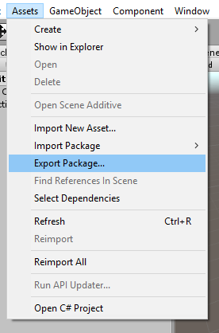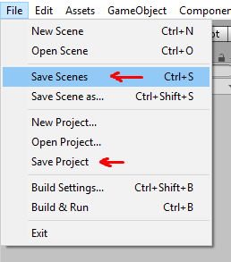

2- Export your project as a Unity package!

Usually, Unity developers dealing with projects they want to buy or sell on the Unity Asset Store(https://assetstore.unity.com) as a packages, so that they could import them to unity with all their assets and scripts without a need for uploading or downloading the whole folder which contains all the assets and usually has a huge size!

To export your project, go to the Assets menu and click on Export package:

3- Check the assets you want to export, or just click on ‘All’ button to export everything in the project. Then click on Export button.

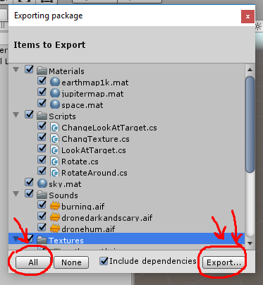

4- Now, name the package with your name_ActivityName or number. And choose a directory.

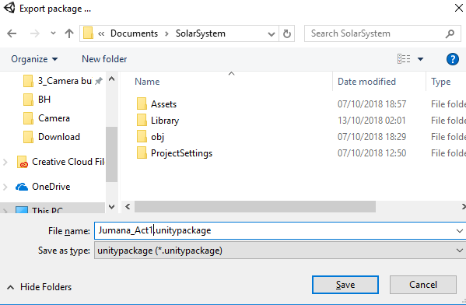

5- Go to the package and compress it in order to send it.

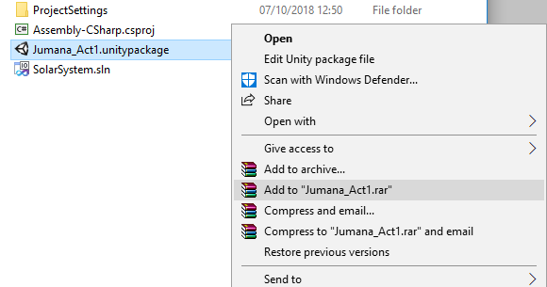

6- Finally, send your compressed file to Ritaj.

Note!

Sometimes, you will not be able to send your file through Ritaj because of its size. In this case you should upload it on Google Drive for example and send the shared link of the file as a message on Ritaj.

You may make a folder on google drive which contains all the activity compressed packages!

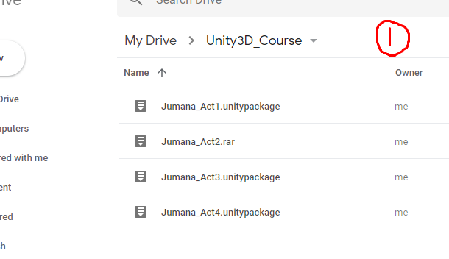

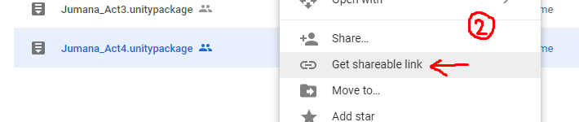

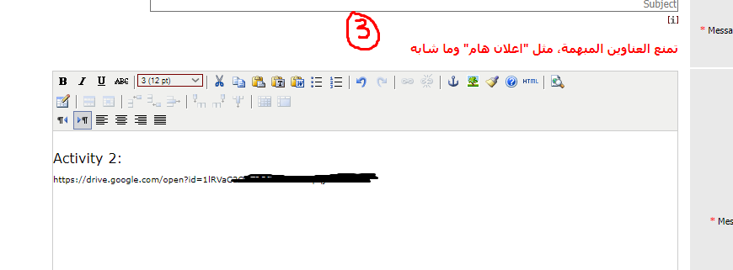

Good Luck :)

# Introduction to Game Design and 3D Modeling

## Game Design

Game design is the process of creating and developing games, from the initial concept to the final product. It involves designing the game mechanics, level layouts, and visual elements, as well as determining the overall theme and tone of the game. Game designers use a variety of tools, including programming languages and game engines, to bring their ideas to life. The goal of game design is to create engaging and immersive experiences for players, challenging them to think critically, solve puzzles, and make strategic decisions. A successful game design requires a balance between fun and challenging gameplay, a compelling narrative, and visually appealing graphics and sound design.

All games share four fundamental traits:

1. **Goals**: All games have goals or objectives that players must strive to achieve. These goals provide motivation and a sense of purpose for the player.
2. **Rules**: Every game has a set of rules that define the mechanics and gameplay. These rules create the structure of the game and guide the player's actions.
3. **Feedback**: Games provide feedback to the player through various means such as visuals, sounds, and text. Feedback lets the player know how they are progressing towards their goals and what actions they should take next.
4. **Voluntary participation**: Playing a game is a voluntary activity, and players choose to engage with the game world and its challenges. This voluntary participation distinguishes games from other activities that people might be required or obligated to do.

Some of the primary things to think about when designing a game:

1. The goal: The goal is the objective that players must strive to achieve in the game. It could be anything from completing a level or puzzle to collecting a certain number of items or points.
2. The obstacles: The obstacles are the challenges that players must overcome to reach their goal. These could include enemies, puzzles, platforming challenges, environmental hazards, and more.
3. The visual representation: The visual representation of the game refers to the overall look and feel of the game world. This includes the art style, graphics, animations, and other visual elements that make up the game's presentation.
4. How you interact with the world: The way players interact with the game world is through game mechanics such as movement, combat, puzzle-solving, and exploration. These mechanics should be intuitive and responsive to ensure a smooth and engaging player experience.
5. The reward for success: The reward for success could be anything from unlocking new levels, gaining power-ups or abilities, earning in-game currency or items, or receiving recognition for their achievements. These rewards help keep players motivated and engaged as they strive to reach their goal.
6. The reward for failure: While failure is often seen as a negative, it can also be an opportunity for players to learn from their mistakes and improve their skills. The reward for failure could be a setback, such as losing progress or having to restart a level, or it could be a learning experience that helps players perform better in the future.
7. The surprise: Surprises are unexpected events or twists that add excitement and unpredictability to the game. They could be hidden areas, secret power-ups, sudden changes in the game's narrative or mechanics, or other surprises that keep players engaged and motivated to continue playing.

Activity 1: Game Analysis

- Choose a game

- describe the gameplay

- Game elements

- Game Rules

- Challenges and reward

- Propose modifying some rules

- Game design sketches and rules

Make sure you submit a full design document for the game.

## 3D Graphics and Modeling

Three-dimensional (3D) graphics and modeling are crucial elements of game design, enabling developers to create immersive and engaging gaming experiences. 3D graphics involve creating digital images that simulate a three-dimensional environment, allowing players to interact with objects and characters as if they were real. 3D modeling, on the other hand, is the process of creating digital representations of 3D objects and characters using specialized software. These models are used to create the visual elements of the game, including characters, environments, and objects. 3D graphics and modeling are essential for creating realistic and detailed game worlds that capture the player's imagination and provide a sense of immersion. Game developers use a range of software and tools to create 3D graphics and models, including 3D modeling software, game engines, and motion-capture technology. By combining advanced techniques and technology, game designers can create visually stunning and interactive gaming experiences that captivate players and keep them engaged for hours on end.

There are various 3D techniques and tools that game developers use to create stunning and engaging video games. Some popular 3D modeling software includes Blender, Maya, and 3ds Max, which are widely used in the game development industry. These software tools provide a range of features such as sculpting, rigging, and animation, which enable developers to create complex 3D models and characters. Additionally, game engines such as Unreal Engine and Unity provide developers with tools to create and manipulate 3D objects, environments, and lighting, among other features. Motion-capture technology is also used to create realistic animations by capturing the movements of actors and translating them into the game's characters. Overall, a wide range of 3D techniques and tools are available to game developers, enabling them to create immersive and visually stunning gaming experiences for players.

Activity2: Comparison of 3D modeling and animation Tools

Conduct a bibliographic research about three modeling tools : Blender, Maya and 3ds Max

Compare these tools using the following metrics:

-Usability in the 3D industry

-Performances

-Functionalities

-Documentation

-…

·Prepare a presentation

## Blender

Blender is a powerful and widely-used 3D modeling software that is popular in the game development industry. It is a free and open-source software, which means that it is accessible to anyone who wants to use it. Blender provides a range of features, including modeling, sculpting, texturing, animation, and video editing, making it a versatile tool for game developers. With its intuitive user interface and extensive documentation, Blender is easy to use and can help developers create complex 3D models and characters quickly. The software supports a range of file formats, making it easy to import and export assets from other software tools. Additionally, Blender has an active and supportive community, providing resources and tutorials for users to learn and improve their skills. Overall, Blender is a powerful and versatile tool that is well-suited for game development, providing game designers with the ability to create high-quality 3D assets for their games.

Blender provides two modes for working with 3D models - **object mode and edit mode**. **Object mode** is used for positioning and transforming 3D objects, while **edit mode** is used for manipulating the vertices, edges, and faces that make up the object. In **object mode**, users can move, scale, and rotate objects, as well as add or remove objects from the scene. Object mode is also used to apply materials, textures, and lighting to objects, making them more visually appealing. On the other hand, **edit mode** allows users to manipulate the individual components that make up the object, giving them greater control over the shape and form of the object. In edit mode, users can select and move individual vertices, edges, and faces, and use tools like extrude, bevel, and loop cut to create more complex shapes. The ability to switch between these two modes seamlessly is one of the key features of Blender, providing users with a flexible and powerful tool for creating 3D models and objects for games.

Activity 3: Blender – Object Mode

Use ten Blender primitive objects and arrange them to create a realistic 3D model.

Objects can only be scaled, moved or rotated. Add material (color) to the object and background.

Submit: .blend file + rendered image.

Activity 4: Multi-Colored Chair – Edit Mode

using only one object, create a chair and color it with more than one color.

Submit: .blend file + rendered image.

Activity5: Bishop (Using Spin)

use the attached image as a background image to draw the chess pawn inside it.

(make the object smooth and colored and use the spin tool).

Submit: .blend file + rendered image.

Activity6: Animation

Bouncing Cube... send the .blend file plus the movie file as in the following link:

https://drive.google.com/file/d/18bdHelnqzK1xne6Qj4lgZouUpBPfdXnp/view?usp=sharing

Please change the colors and make them 3 changing colors of your choice.

# Game Development Using Unity

* 1. **Install Unity**

Head to[http://unity3d.com/](http://unity3d.com/unity/download)anddownload the Unity3Dinstaller for *free*! It's a large file so be patient! Run it after it downloads.

While downloading, make sure you have an e-mail account. You need it to finish installation!

You will install unity hub.

1. **Open Unity Hub**

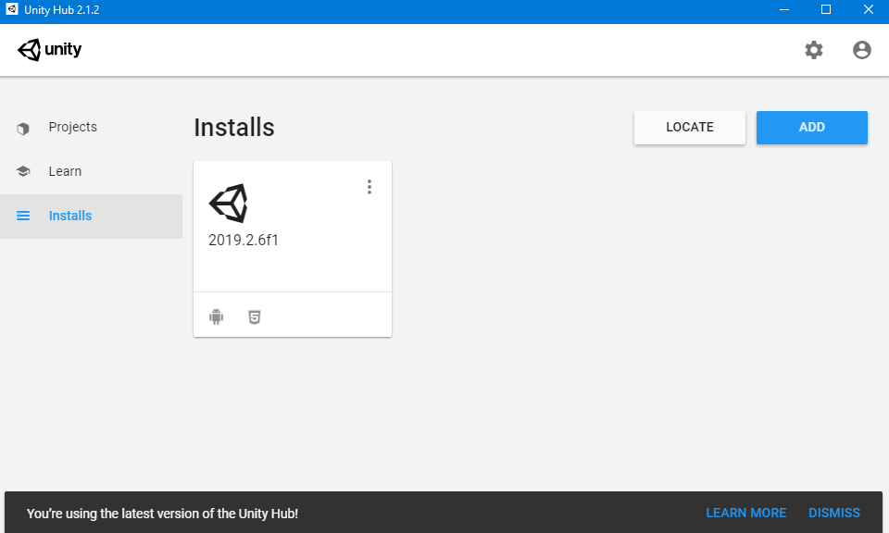

1. Click on add button

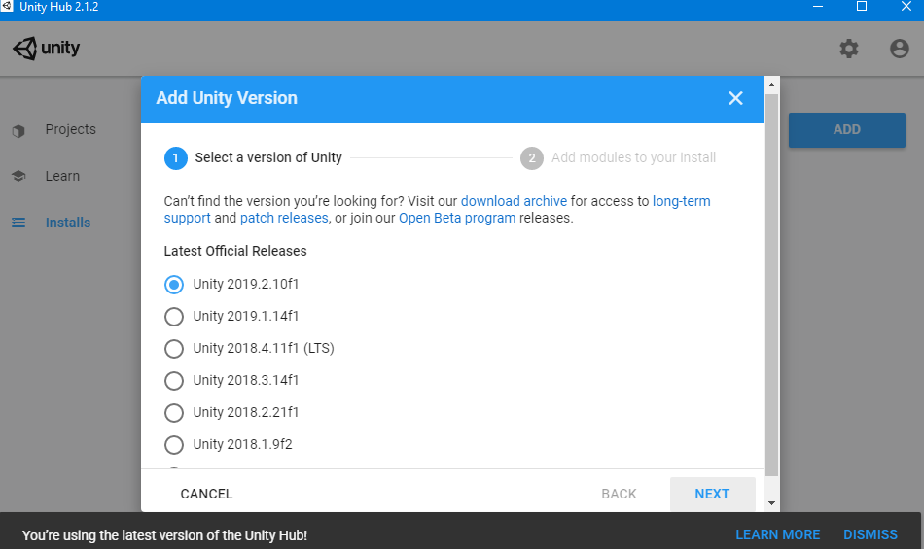

1. Select the needed version and install it!!

* 1. **Create a Project (in Windows)**

1. Open unity hub
2. Click on projects, then new

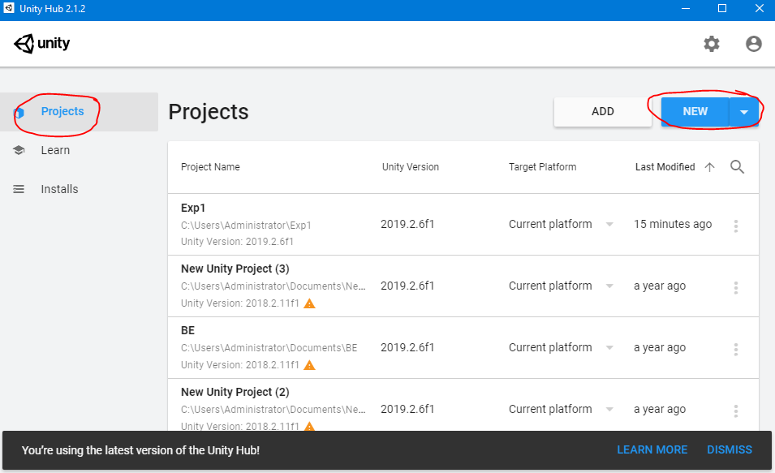

1. Select the needed templet and rename the project then click create.

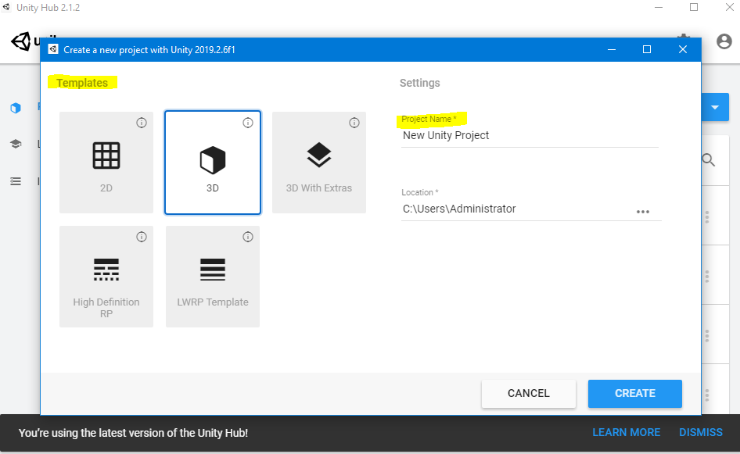

* 1. **Pick a User Interface Layout**

Choose a User Interface layout using the drop-down menu (****) on the upper-right.

Below is an example of the **Tall** User Interface (or UI for short):

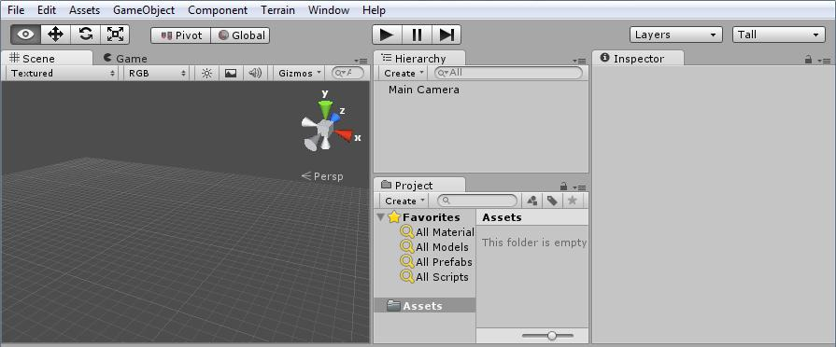

Make sure you can find ****, ****, ****, and ****.

(If you lose any UI, check  , or reset the layout with the drop-down menu).

* 1. **Use the Scene User Interface**
* 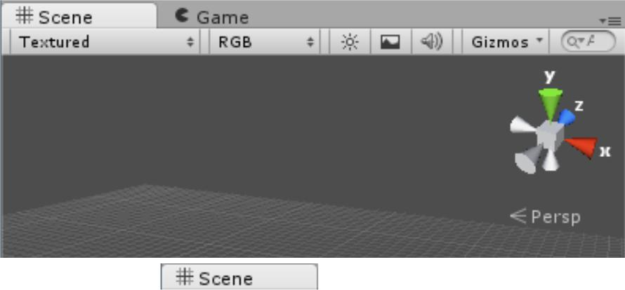Find your  User Interface. It looks something like this:
* The  User Interface is used while *play-testing* your game. If you accidentally click into that UI, just Click on  again.
* You can *toggle* (turn on and off) the *grid.*
* Plane with  The grid can help with a sense of distance and scale while editing.
* Turn the camera by holding the **Right-Mouse Button** and moving the mouse. Turning with the mouse like this is called *Mouselook*.
* While holding the **Right-Mouse Button**, *move* the camera in the  using **W**, **A**, **S**, and **D**. If you have ever played Minecraft, or another First Person Shooter on a PC, this should be easy.
* 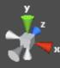Notice the 3D **Scene Gizmo** at the Upper Right of the ****. You'll notice it move when you M*ouselook*. It's diagramming the *XYZ Axis*.
* You can imagine the XYZ Axis in real life using a hand gesture, like this:
  + 1. The Z axis (Depth) is forward, along your pointer finger
    2. 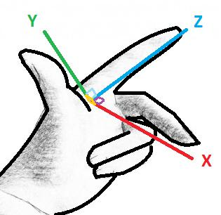The Y axis (Height) is up, along your thumb
    3. The X axis (Width) is to the side, along your middle finger
  + If you've studied Algebra or Geometry, you might have seen an *XY Grid*, also called a *Cartesian Plane*. The XY*Z* Axis is like that, but with a Z dimension too!
  + If you Click on the cube in the center of the 3D Scene Gizmo, you will toggle how the camera draws 3D, between Perspective and Isometric.
    1. 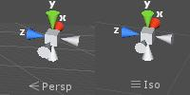Perspective is how we see in real life.
    2. Isometric is helpful for lining up objects that are far away.

The  will help you organize your game, in 3D space.

* 1. **Use the Hierarchy User Interface**
  + The  will help you organize your game as a list of **Game Object**s

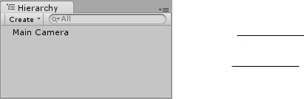

* + Everything currently in the game **Scene** will be listed here!
  + You can add a new element to the game with ****.
  + *Quickly* **Double-Click**on an element in the  **,** the  will adjust to show it to you.
  + *Slowly* **Double-Click**on an element in the ****, you can rename it!
  + Press  and select ****. It should appear in the ****, and the.



* + - If you cannot see the new Cube, double-click on its name in the ****.
    - Create a with  and ****.
    - Don't be afraid to experiment by creating other **Game Object**s. You can **Undo** (**Ctrl + Z**) almost anything, including adding a new object. To **Delete** an extra object, select it and press **Delete**, or press the **Right-Mouse Button** over the object in the  and select ****from the menu.



* You can also find the same create menu through ****, ****.
* Move around the scene using **W,A,S,D** and *Mouselook*, to see where the **Cube** and **Point Light** are in relation to each other.



* 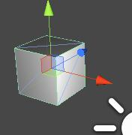If you don't see the **Translate Gizmo** (as pictured to the right), press ****, in the upper-left of the Unity3D UI.
* Move the **Cube** and **Point Light** closer together with the **Translate Gizmo**

(colored *Arrows* and *Planes* in the ). **Drag** the *Arrows* with your mouse, or **Drag** the *Planes* between the lines of the arrows.



* The **Cube** should light differently in the  as the **Point Light** moves. If not, press ****, at the top of the ****, to toggle lights.

* 1. **Use the Inspector User Interface**

**1** Select an object in the  or  and you'll see its details in the ****.

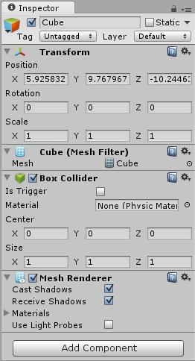

You can rename an object with the text field at the top.

Hide this object if you un-check  next to the name.

All **Game Objects** have a ****, which can

be changed with the text boxes. The **Transform**

of:

* + - 1. **Position** in XYZ space
      2. **Rotation**, which is how it is turned, on the XYZ axis
      3. **Scale**, which is how it is stretched across the XYZ axisYou can also use other **Gizmos** and the mouse to change

**Position** , **Rotation** , and **Scale** . The buttons that enable those **Gizmos** are at the top-left of the Unity User

Interface, in a panel that looks like .

1. You might see these **Component**s somewhere in your **size**

:

**• **: makes the cube *model*, or **Mesh**

**• **: makes the cube collide-able like a box

**• **: allows **Game Object** to render (show)

**•** : set a light, with color, brightness, and more

**•** : will **render** a *view* to the screen

**•** : allows *lens-flares* to be rendered

**•** : allows custom **GUI**s to be rendered

**•** : allows sounds to be heard in-game

1. Select your Cube. You can click on it in the ****, or in the **.**
2. Set the Cube's **Position** to ****. You can change each

number by selecting the text-box with the number in it, and typing in a new number.

1. Set the Cube's **Scale** to ****.

5 Rename your Cube toground.

6 **Double-click** ongroundin the  to auto-adjust the  to view it.

7 If you don't have a **Point Light**, create one. Set your **Point Light**'s **Position** to

****.

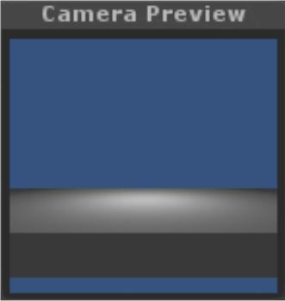

* + Select the **Main Camera** to see **Camera Preview** in the ****.
  + Move around in the  with **WASD** and *Mouselook* (while holding
  + the **Right-Mouse Button**), then with the **Main Camera** still selected, from the
  +  menu, select
  + ****, or just press **Ctrl + Shift + F**.
  + You should notice the **Camera Preview**, and the  changed.
  + This (**Ctrl + Shift + F**) can change any selected ****.

7. Use the Project User Interface

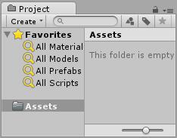

**•**  is a list of **Assets** (**Game Object**s, pictures, sound, scripts, ...) that *could be* in your . It's different from the , which is a list of **Game Object**s that *are* in your  .

You can **Import** new assets with the  menu item.

The **Assets** folder in  mirrors the actual file system! To see it in *Windows Explorer*, press the **Right-Mouse Button** on ****, then ****.

1. To import a **Character Controller** from the **Standard Assets** Library, select the  menu, then

 and ****.

1. To keep things simple, just press ****, and wait for it to load. Or to make the project smaller, un-check the  at the **3rd Person Controller.prefab**, and every file within **PrototypeCharacter/**, including **Constructor.FBX**, **constructor_done.mat**, **constructor_diffuse.png**, and **constructor_normals.png**.
2. The  folder in  now has an arrow ****. **Click** the arrow to toggle folder listing.



1. Select the **Character Controllers** folder, which is inside of the **Standard Assets** folder.

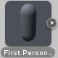

1. Select the **First Person Controller**, which looks like a *Capsule*, which is a rounded *Cylinder*.
2. *Drag-and-drop* the**First Person Controller**into the 

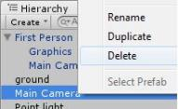There are now 2 **Main Camera**s in your Game! The **Scene** started with

one, and the **First Person Controller** came with one as well!

**Delete** the **Main Camera** that was in the **Scene** *first*, the one ***not*** inside

the **First Person Controller**. Select it and press **Delete**, or press the

**Right-Mouse Button** over the **Main Camera** and select **Delete**.

This is not required, but may help with debugging scripts later!

1. Set the **Position** of the **First Person Controller** to 
2. Rename the **First Person Controller** to something like “player”, to help keep things simple for later.



1. **Save** your **Scene** by selecting ****, and  (or press **Ctrl + S**). Name it



something like “tutorial”, and be sure to save it in the **Assets** folder, or in a folder inside of it.

1. **Save** often, especially before you try something new that you have never done before!

8.Play-Test

1. Press the Play  button (in the middle, near the top, with one of these buttons ****)

**2** The  user interface is now active, and the rest of the UI changed color *very slightly*.

**3** To move the **First Person Controller** (that was renamed toplayer), move the mouse (*Mouselook*), and

use the **WASD** keys for movement, just like in the ****. You can use **Space Bar** to jump!

**4** If you fall, you can stop and restart the game by pressing ****.

**5** If your game seems broken, set theplayer's **Position** to ****.

Also, make sure you have a ground cube at **Position ** andthe ground cube's **Scale** of ****.

**6** While the game is playing, select theplayerin the ****, then **Click** back into the**** to give mouse and keyboard *focus* back to the game. Notice that when you move theplayer, the  shows the new state of the player's ****.

1. You can change the details of any **Game Object** *while the game is running* with the ****.
2. You should adjust your Unity settings to *more* clearly show when the game is running, so you don't accidentally make changes that can't be saved. Go to , , , and change the

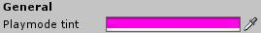 to something obvious. Like, hot pink.

* + 1. **Click** on the colored rectangle, and select a color using the color chooser.

9.“Iterate” On Your Game

* + *Iterate* means *to do something over-and-over again*. Game Developers use that word to describe theworking on a game. Most of real Game Development is the same thing over and over:

1 Come up with an idea to try

2 Use tools (like Unity3D) to try it out

3 Test it out, to see if it works like expected

4 If it doesn't work, or there's more to do (almost always there is), go back to the first step!

* + This is also called the *Iterative Process*, and it is also similar to the *Scientific Method*.
  + Try to add more **Game Object**s and move them around to create a more interesting **Scene**:



* + Try to use several cubes and lights to build a maze. You can **Scale** the cubes into walls, and even additional ground *platforms*!

1. Add lighting. Don't be afraid to edit objects in the ****. Unity can **Undo** (**Ctrl + Z**) and **Redo** (**Ctrl + Y**) any of your changes. Also, don't forget to save often (**Ctrl + S**)!



* + *Play-test* your game after making some changes, to see if it is more fun!

1. You could try to make a simple maze, like this (6 **Cube**s, 2 **Point Light**s, and a **First Person Controller**):

To **Duplicate** a **Game** **Object**, press the

**Right-Mouse Button** over it in the  andselect **,** orselect it and press **Ctrl + D**.

For more*digital*(or*snap-to-grid*) controlwhile adjusting

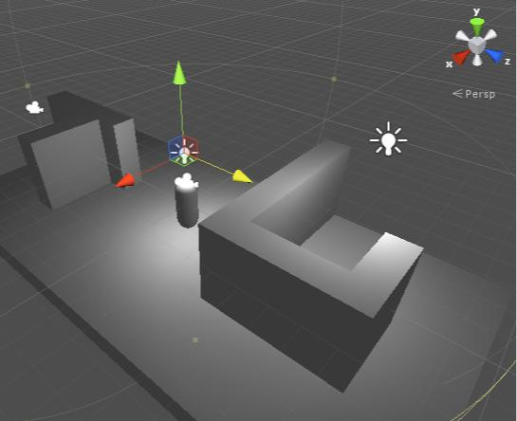**Game Object**s with the **Position** ,

**Rotation** , and

**Scale**  **Gizmos**,hold **Ctrl**, while **Drag**ging the

mouse.



Add Material and texture to your scene!

Activity 2.1: Cube Rotation – in Class

Submit your package.

Activity 2.2: Discover Unity Interface and Object Manipulation.

In this activity, we are going to learn how to make a new project, what does different windows include and how to use Unity’s navigation, position, rotation and scale tools.

1. Start Unity and click File -> **New Project**
2. Select the location of the project and **name it**
3. You can import a default package from here but you can also import them later. Let’s not import anything this time. Let the **3D** defaults be selected and then press create.
4. Now we have an empty project. Let’s save the scene we are starting to work on. Click ‘**File -> Save Scene As’** and name it as you like (MainScene for example). The scene should now display in our Project view in the Assets folder. This view includes all our assets. You will learn more about assets in the next tutorial. (you can create new scene). Save the scene in the **scenes folder,** (if the scene folder is not exist, create one.)
5. Now let’s start adding visible things in our scene by adding a plane. You can add a plane in to your scene from ‘GameObject -> Create Other -> Plane’ or from the Hierarchy view by clicking the Create and then Plane.
6. Select the plane you just made from the Scene view or from the Hierarchy view. You can make the plane to be exactly in the center of the scene by manipulating the Transform component from the Inspector view. Set the values as you see in the image below.



1. You can **rename** the plane from the Hierarchy view by selecting the plane and clicking its name. Name it a Floor for example.



1. **Create a cube**. You can do it from the GameObject menu or from the Hierarchy views Create menu.
2. **Change the scale of the cube** from Transform component to

Scale: X: 5, Y: 5, Z: 5

Notice how the half of the cube is below the plane. You can fix this by changing the cubes Y position to 2.5. Your scene should look like in the image below.



1. Now take the Position tool (W) from the upper left corner of the interface. Use it to **move the cube near the corner**. When the cube is near the corner, you can just change the position from the Transform component so that the cube is exactly in the corner. You can see the exact values from the image below.



1. Now we’re going to **make three more cubes** so that **each corner has a cube.** Right click the cube in the Inspector view and click Duplicate. You can do this also by pressing CTRL + D.
2. There is a new cube in the Inspector view now, but you cannot see it in the scene view. That’s because the cube is in the same position as the cube you just duplicated it from. You could **change its position** with the Position tool or by changing the values from Transform component but let’s use snapping this time.
3. Click the Edit menu and then click the last option called Snap Settings. Change the move X, Y and Z values to 5.
4. Select the Position moving tool from the upper left corner (W) and press CTRL and move the cube. Notice how **the cube now moves 5 units per step**.
5. **Move the cube to another corner**, duplicate it and repeat this so you have one cube in every corner. The scene should look like in the image below.



1. Make a new cube. Modify the values from the Transform component like in the image below:



Notice how you need to modify the Y position from 2.5 to 2 because the Y scale is now one unit smaller.

1. Open the **snap settings** again and set **the Rotation to 45**. Now duplicate the cube, choose the Rotation tool (E), press CTRL and rotate the cube 90 degrees. The cube should now rotate in 45 degree steps. Place the cube between two other corner cubes, duplicate and repeat so you have a scene like in the image below.



1. Apply material to the objects. (wood texture for the rectangles, brown material for the corners). See activity 2 and 3.
2. Save your new Scene and new Project.

Now we have a new project and a scene with a “sandbox” in it.

Note:

Export your project into unity package to be sent:

Go to asset Menu -> export package -> Select all -> choose location.

Activity 2.3: Creating Simple Material

Creating simple material:

**Create the sphere:**

1. From the top menu, select GameObject -> 3D Object -> Sphere.

2. Use the transform tools to **position the new sphere** so that you can see it in the Scene view.

3. Use the Transform section of the Inspector panel to increase the Scale to 5 for the X, Y, and Z Scale parameters. This will help make the sphere larger and easier to work with.

**Create material:**

1. In the Project panel, click Materials, and then right-click in the folder and select Create -> Material

2. Name the new material red

3. With the new material selected, click the **color box in the Main Maps section** of the Inspector panel

4. In the color selector window that pops-up, **select a red color** and then close the selection box

Your new material, when viewed in the Inspector panel.

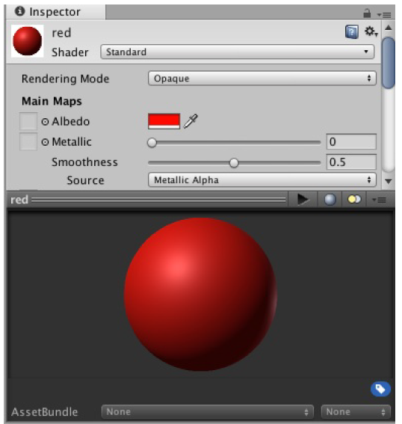

**Apply the material to the sphere:**

With the sphere selected in the Hierarchy panel and the Materials folder selected in the project panel, **drag the red material from the Materials folder to the Inspector panel Mesh Renderer component**, in the Materials -> Element 0 parameter.

Good Luck.

Activity 2.4: Applying Textures, Shaders, and Materials to Models

Applying Textures, Shaders, and Materials to Models.

Follow these steps to put all your knowledge of textures, shaders, and materials

together to create a decent-looking brick wall:

1. Start a new project or scene. Note that creating a new project causes the editor to close and reopen.
2. Create a **Textures** folder and a **Materials** folder.
3. Locate the Brick_Texture.png file and **drag it into the Textures folder** created in step 2.
4. **Add a cube** to the scene. Position it at (0, 1, -5). Give it a scale of (5, 2, 1).
5. **Create a new material** (by right-clicking the Materials folder and selecting Create > Material) and name it BrickWall.
6. Leave the shader as Standard, and **under Main Maps click the circle selector** (the little circle icon) to the left of the word Albedo. Select Brick_Texture from the pop-up window.
7. Click and **drag the brick wall material from the Project view onto the cube** in the Scene view.
8. Notice that the texture is stretched across the wall a little too much. With the material selected, **change the value of the x tiling to be 3**. Make sure you do this in the Main Maps section, not the Secondary Maps section. Now the wall looks much better. You now have a textured brick wall in your scene. The figure below shows the final product.



Activity 2.5: Solar System (Part 1)

1. Objects Creation
   1. Create a sphere of 3m diameter in (0, 0, 0). Rename it Sun
   2. Create another sphere of 0.5m diameter in (7, 0, 0). Rename it Earth
   3. Create a Point Light of Range 25 and intensity 8 in (0, 0, 0)
   4. Parent the light with the Sun
2. Texturing
   1. Manipulate the 3D view for both Earth and Sun to be visible
   2. Align the camera to the 3D view when appropriate
   3. Download the Earth texture from Moodle and place it on the small sphere
   4. Download the Sun texture from Moodle and place it on the big sphere
   5. In the inspector, open the shader of the Sun and put the sun texture in Emission, to give the impression that the sun is shining (emitting white light)
3. Scripting

* Build a script to simulate the motion of a planet and rotate the Earth.
* On itself: use the method?
  + - Add the function Transform.Rotate (.............); to the update loop.
* Around the sun
  + - Use the function Transform.RotateAround (...........);
* make an external reference to the Sun

submit your package.

Save your work, you will continue on it later.

Activity 2.5: Solar System (Addition)

Please use the same solar system you did in the previous activity and add the following:

make the sun light change its color every 5 seconds.

Submit your package.

# Scripts

Activity 3.1: Starting scripts

**Creating a Script**

Follow these steps to create a script for use in this section:

1. Create a new project or scene and add a **Scripts** folder to the Project view.
2. Right-click the Scripts folder and choose **Create > C# Script**. Name the script **HelloWorldScript**.
3. Double-click the new script file and wait for Visual Studio to open. In the editor window of Visual Studio (refer to Figure below), erase all the text and replace it with the following code:

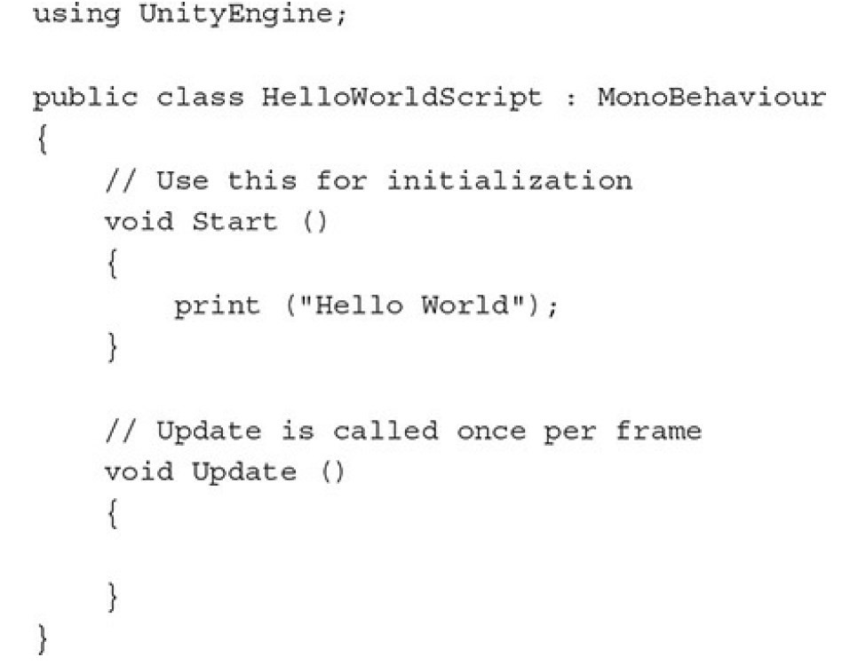

1. Save your script by selecting File > Save or by pressing Ctrl+S (Command+S on a Mac). Back in Unity, confirm in the Inspector view that the script has been changed and run the scene. Notice that nothing happens.

The script was created, but it does not work until it is attached to an object, as discussed in the next section.

**Attaching a Script**

5. Attach the script HelloWorldScript that you created earlier to the Main Camera (by drag and drop). You should now see a component named Hello World Script (Script) in the Inspector view. If you run the scene, you see Hello World appear at the bottom of the editor, underneath the Project view.

**Try the prinf function:**

• add the following line of code to the Start method,

print ("Start runs before an object Updates");

* look at the console
* add the following line of code to the Update method, look at the console

print ("This is called once a frame");

**Modifying Public Variables in Unity**

Follow these steps to see how public variables are visible in the Unity editor:

1. Create a new C# script and in Visual Studio add the following line in the class above the Start method:

public int runSpeed;

1. Save the script and then, in Unity, attach it to the Main Camera.
2. Select the Main Camera and look in the Inspector view. Notice the script you just attached as a component. Now notice that the component has a new property: Run Speed. You can modify that property in the Inspector view, and the change will be reflected in the script at runtime. Figure 7.6 shows the component with the new property. This figure assumes that the script created was named ImportantFunctions.

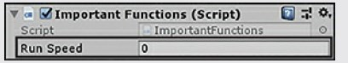

**Make a rotation on a cube**

1. Add a cube
2. Create scripte call it Rotate
3. Add the function **Transform.Rotate (0,5,0)**to the update loop
4. Attach the script to the cube
5. Click play to test

**Use of public variables**

1. Modify the above script so that the Rotate function will take the speed variable.
2. **transform.Rotate(0, speed, 0);**
3. define the speed variable as public **public float speed = 5.0f;**
4. play to test
5. try with private speed, then test again, see the difference.
6. Return it to public

Activity 3.2: Script Transform

Follow these steps to see how to apply the code to an object in a scene:

1. Create a new project or scene. Add a cube to the scene and position it at (0,-1, 0).
2. Create a new script and name it CubeScript. Place the script on the cube. In Visual Studio, enter the following code to the Update method:

transform.Translate(.05f, 0f, 0f); transform.Rotate(0f, 0f, 1f);

transform.localScale = new Vector3(1.5f, 1.5f, 1.5f);

1. Save the script and run the scene. You may need to move to Scene view to see the full motion. Notice that the effects of the Translate() and Rotate() methods are cumulative, and the variable localScale is not; localScale does not keep growing.

## Prefabs

Activity 3.3: Create Prefabs

Create a prefab to hold our sphere (created in activity 2 with red material).

Follow these steps:

1. In the Project panel, select the **Prefabs folder**.

2. Right-click on the Prefabs folder and select **Create -> Prefab**. Alternatively, you could have selected, from the top menu, Assets -> Create -> Prefab.

3. **Name the prefab “bloodDroplet**”. You will notice that there are no components or properties visible in the Inspector panel for the new prefab.

4. Next, **drag the Sphere GameObject from the Hierarchy panel to the new bloodDroplet prefab in the Project panel**. Now, when you view the prefab in the Inspector panel, you can see the components and properties that our sphere had.

5. We no longer need the original sphere, so **delete that** in the Hierarchy panel.

Now that we have a bloodDroplet prefab, we can drag it into our scene as many times as we want. We can also add them to our scene using scripts.

To experience the power of prefabs in Unity, try the following:

1. **Select the bloodDroplet prefab** in the Project panel.

2. **Drag several copies** of the bloodDroplet prefab into your scene.

3. In the Inspector panel, **change the color**. You will notice that all the bloodDroplets in your scene were changed based on the change you made to the prefab.

4. Return the color of the prefab to the red material.

5. Delete any bloodDroplets from your scene. This is most easily done in the Hierarchy panel.

Note: Deleting the blood Droplets from your scene does not remove all bloodDroplets from your game. Because we have the bloodDroplet prefab, we can add bloodDroplets to our scene at any time.

Scripting – Instantiate

* + - **instantiate** is a function which simply creates an instance of a prefab in the scene. Here’s an example of instantiation of a GameObject.

**void update()**

**{**

**// Instantiate the prefab at position (0, 0, 0) with no rotation**

**Instantiate(prefab, new Vector3(0, 0, 0), Quaternion.identity)as Transform;**

**}**

* + - This script instantiates a prefab, gives it position ‘x:0, y:0, z:0’ and no rotation.

Activity 3.4: Instantiate function

1. Create a script called SceneController to create an enemy if there are no enemies in the scene:  
2. You should have an enemy prefab to be attached to the script.  
3. Use the instantiate function.  
4. Position the new created element in (0,1,0).  
5. Rotate it in random angle on z.

**Modification:** **Make the script create a new object in a random position each time the Space key is clicked.**

# **Scripts - Input**

Activity 4.1: Scripts – Keyboard Movement

1. Create a new script and name it *KeyboardMovement*.
2. We want to move the cube in the four directions: up, down, left, and right depending on which keyboard arrow key the player is pressing.
3. Call Input. GetKey() and pass to it a **key code** to check its state. For example: Input.GetKey(KeyCode.RightArrow)
4. The KeyCode enumerator includes codes for all keyboard keys, so we only have to choose the appropriate one. Input.GetKey() returns true if the given key is pressed during the current frame, and returns false otherwise
5. Using if keyword, we build conditional statements that bind movement to certain direction by a specific key on the keyboard. Here we use again transform. Translate() to move the object on x and y axes, and use positive and negative values of speed to specify the movement direction.
6. Add the script to the cube and start the game to move it using the keyboard arrow keys.

Difference with Input.GetKey**Down**(),

* For reading the key only once instead of the repetitive reading in every frame. For example: the jump action in platformer games usually requires the player to release the jump button/ key and press it again to make a new jump, instead of jumping continuously by simply keeping the jump key pressed.
* Use Input.GetKeyDown(), which gives us true only at the first time the player presses the key. After that, it keeps returning false until the key is released and pressed again.

public float speed = 10;

Inside Update

//Check up

if(Input.GetKey(KeyCode.UpArrow)) {

transform.Translate(O, speed * Time.deltaTime, 0);

}

//Check down

if(Input.GetKey(KeyCode.DownArrow)) {

transform.Translate(O, -speed * Time.deltaTime, 0);

}

//Check right

if(Input.GetKey(KeyCode.RightArrow)) {

transform.Translate(speed * Time.deltaTime, O, 0); }

//Check left

if(Input.GetKey (KeyCode.LeftArrow)) {

transform.Translate(-speed * Time.deltaTime, 0, 0); }

Activity 4.2: Exercise – Input

Create a new project and place a cube in (0, 0, 0).

Create a Keyboard folder and save the keyboard scene in it.

Create a script named Keyboard and drag it to the cube.

Code the following interactions with methods of the Transform class:

* Method Rotate (Vector3 axis, float angle)
* When you press the left directional arrow, the cube will rotate clockwise and continue the rotation while pressing.
* When you press the right arrow, the cube will turn counterclockwise and continue the rotation while pressing.

in both case when the player stops pressing the arrow the cube will stop rotating and the rotation period will be displayed in the console.

## Raycating

* In the script :  
  void Update () {  
  Ray ray = Camera.main.ScreenPointToRay (Input.mousePosition);  
  RaycastHit object;  
  if (Physics.Raycast (ray, out object, Mathf.Infinity)) {  
  Debug.Log (objet.transform.gameObject.name.ToString ());  
  }  
  }
* The RaycastHit class has many interesting attributes to learn about the object hit by the ray.  
  Among them :
  + distance: length of the radius from its origin to its point of impact (in our case, object.distance)
  + point: precise point of impact of the ray on the hit object (in our case, object.point)

Activity 4.3: RayCast

Create at least 3 different objects,

1- when the player clicks on one object, its color becomes red.

2- move the clicked object and drop it using the LMB (like drag and Drop).

3-destroy the clicked object (RMB).

4- If RMB clicked and there is no objects in the scene, then create a new one (note: you should have a prefab object).

Activity 4.5: Mouse Movements

Create one object, move it according to the mouse movements.

Activity 4.6: Mouse Movements - 2

1. Let's begin with a new simple scene that has one object: a sphere located at the origin.

2. Add a script to this sphere that reads the clicks on mouse buttons and use them to change the color of the sphere.

3. The script will also read mouse movement and interprets it to displacement of the sphere on x and y axes.

4. Finally, mouse wheel scrolling will be used to change the scale of the sphere It is advised that you position the camera in a relatively far distance from the sphere (0, 0, -70 for example), which should prevent the sphere from leaving the field of view easily.

Activity 4.7: Mouse Movement – 3

In this exercise, you’ll read in mouse movement and output the results to the Console:  
1. Create a new project or scene. Add to the project a script named PlayerInput (or modify the existing one) and attach it to the Main Camera.  
2. print through the Console to see the mouse x and y axis when you move the mouse around.  
4. Change you script so that when the mouse moves on x or y axis the object moves accordingly.  
5 – don’t fogest to create an object (cube for example) and apply the script on it.  
Next.....  
6- Move the object on which the user is clicking by left and right arrows

Activity 4.8: Touch Detection – 1

The aim of this activity is to learn how we can detect touches on our screen for when we create mobile games for touch phones.

In this activity, we will create a 3D object (a ball) which will change color to a random color when it is touched. We will create the game to be built for an Android device, so first you need to make sure the Android SDK is installed, then, follow the steps below:

1. Open a new Unity 3D project.
2. Create a new 3D object, in this activity we created a sphere to represent a ball.
3. Create a new C# script name it ColorChanger.
4. Attach the script to the main camera.
5. Open your script and let’s start with the code below

void Update()

{

if(Input.touchCount > 0 && Input.touches[0].phase == TouchPhase.Began)

{

Ray ray = Camera.main.ScreenPointToRay(Input.touches[0].position); RaycastHit hit;

if(Physics.Raycast(ray, out hit))

{

if(hit.collider != null)

{

Color newColor = new Color(Random.Range(0.0f, 1.0f), Random.Range(0.0f, 1.0f), Random.Range(0.0f, 1.0f), 1.0f); hit.collider.GetComponent<MeshRenderer>().material.color = newColor;

}

}

}

}

Now let us have another look at the code to understand what is going on.

1. We added our lines on code in the Update() method.
2. if(Input.touchCount > 0 && Input.touches[0].phase == TouchPhase.Began) This line acts as an input touch listener and watches out for the number of touches that occur, in our case we want to make sure that it is > 0 which means at least one touch has happened.
3. Ray ray = Camera.main.ScreenPointToRay(Input.touches[0].position);

RaycastHit hit;

Once our touch has been detected we set out a Ray to catch the detected object.

1. if(Physics.Raycast(ray, out hit))

{

if(hit.collider != null){

Color newColor = new Color(Random.Range(0.0f, 1.0f), Random.Range(0.0f, 1.0f), Random.Range(0.0f, 1.0f), 1.0f); hit.collider.GetComponent<MeshRenderer>().material.color = newColor;

}

}

Once we detected an object, we retrieved the object and performed the action we wanted. In this case, we created a new object from the Color class and used it to change the color of our ball.

Next, Go to file - > Build Settings -> Add Open Scenes -> Build (this will build your project, and you will be able to download the project APK).

1. Copy the build file to your phone (Android).
2. From your phone install the app, and it should be ready to go.

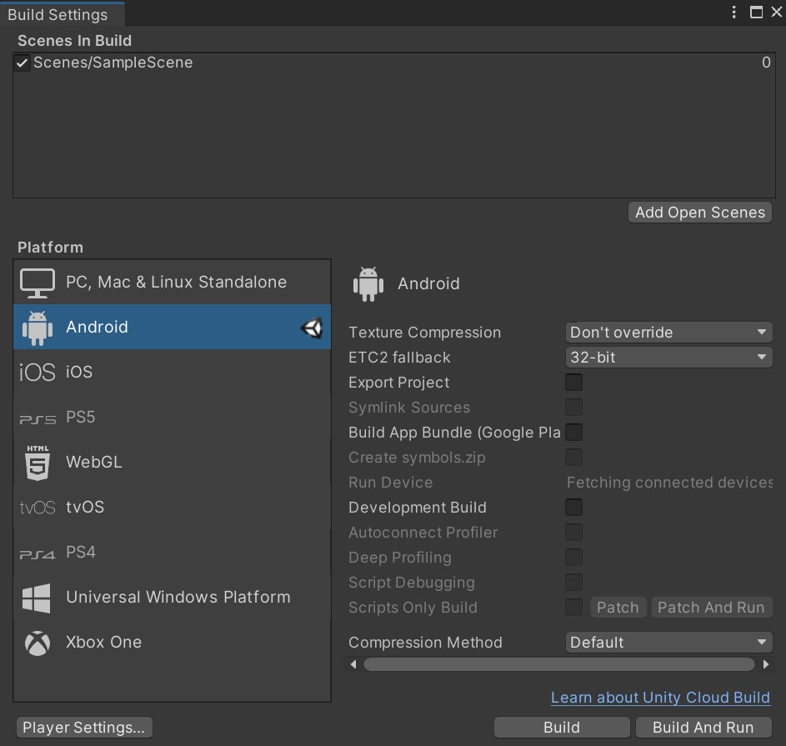

Activity 4.9: Touch Detection – 2

1. Make sure Android or iOS SDK is installed depending on what OS you are using, for this activity we will be using Android.
2. In your new project, add a cube and center it at (0, 0, 0).
3. Name your cube player.
4. Create a script called TouchGame and drag it to your player (cube).
5. Add the following code to your script:

public Transform player;

// Start is called before the first frame update void Start()

{

}

// Update is called once per frame void Update()

{

if (Input.touchCount > 0 && Input.GetTouch(0).phase ==

TouchPhase.Stationary)

//The previous lines detect whether the user is touching the screen and the finger has not moved.

{

Vector2 touchPosition = Input.GetTouch(0).position; double halfScreen = Screen.width / 2.0; //The previous lines get the position of the touch.

//Check if it is left or right?

if (touchPosition.x < halfScreen)

{

player.transform.Translate(Vector3.left * 5 * Time.deltaTime);

}

else if (touchPosition.x > halfScreen)

{

player.transform.Translate(Vector3.right * 5 * Time.deltaTime);

}

}

}

1. Go to file - > Build Settings -> Add Open Scenes.
2. Select Android (or iOS if that is what you are working on).
3. Build (this will build your project, and you will be able to download the project APK).



1. Copy the build file to your phone (Android).
2. From your phone install the app, and it should be ready to go.

# Camera, Lights, Assets and Prefabs.

## Camera

Activity 5.1.1: Working with Multiple Cameras

The best way to understand how multiple cameras interact is to get some practice working with them. This exercise focuses on basic camera manipulation:

1. Create a new project or scene and add two cubes. Place the cubes at **(-2, 1,-5)** and

**(2, 1, -5)**.

1. Move the Main Camera to **(-3, 1, -8)** and change its rotation to **(0, 45, 0)**.
2. Add a new camera to the scene (by selecting **GameObject > Camera**) and position it at **(3, 1, -8)**. Change its rotation to **(0, 315, 0)**. Be sure to disable the audio listener for the camera by unchecking the box next to the component.
3. Run the scene. Notice that the second camera is the only one displayed. This is because the second camera has a higher depth than the Main Camera. The Main Camera is drawn to the screen first, and then the second camera is drawn on top of it. **Change the main camera depth to 1** and then run the scene again. Notice that the Main Camera is now the only one visible.

Activity 5.1.2: Creating a Split-Screen Camera System

Here we will create a split-screen camera system. This type of system is common in two-player games where the players have to share the same screen. This exercise builds on the previous Follow these steps:

1. **Open the project** that you created in the preceding activity.
2. Ensure that the **Main Camera has a depth of -1**. Ensure that the X and Y properties of the camera’s View Port Rect property are both 0. Set the W and H properties to 1 and 0.5, respectively (that is, 100% of the width and 50% of the height).
3. Ensure that the second camera also has a **depth of -1.** Set the X and Y properties of the view port to (0, .5). This causes the camera to begin drawing halfway down the screen. Set the W and H properties to 1 and .5, respectively.
4. Run the scene and notice that both cameras are now projecting on the screen at the same time (see Figure below). You can split the screen like this as many times as you want.

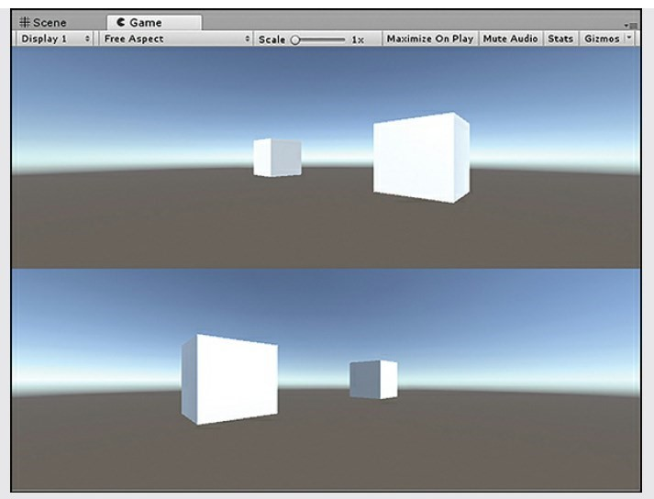

Activity 5.1.3: Creating a Picture-in-Picture Effect

Picture-in-picture is commonly used to create effects like minimaps. With this effect, one camera draws over another one in a specific area. This exercise builds on the previous one for multiple cameras:

1. **Open the project** that you created in the previous activity “Working with

Multiple Cameras.”

1. Ensure that the Main Camera has a **depth of -1**. Ensure that the X and Y properties of the camera’s Normalized View Port Rect property are both 0 and the W and H properties are both 1.
2. Ensure that the **depth of the second camera is 0**. Set the **X and Y property of the view port to (0.75, 0.75)** and set both the **W and the H values to .2**.
3. Run the scene. Notice that the second camera appears in the upper-right corner of the screen (see Figure below). Experiment with the different view port settings to get the camera to appear in the different corners.

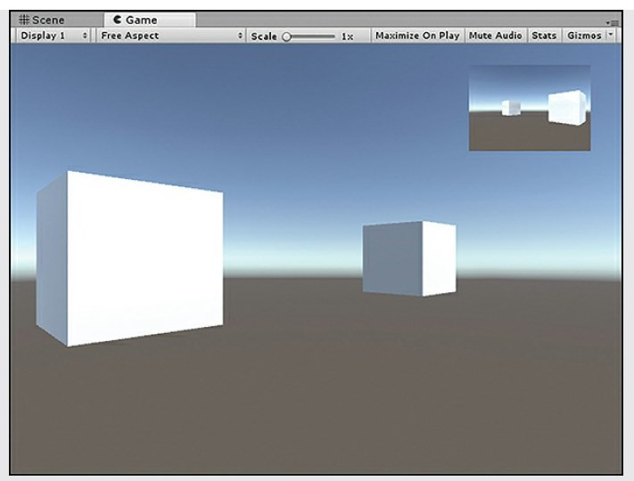

Activity 5.1.4: Exercise:

In this exercise, you have a chance to work with multiple cameras and lights. You have a bit of leeway in the construction of this exercise, so feel free to be creative:

1. Create a new scene or project. **Delete the directional light**. **Add a sphere** to the scene and place it at (0, 0, 0).
2. **Add four point lights** to your scene. Place them at **(-4, 0, 0), (4, 0, 0), (0, 0, 4)**, and **(0, 0, 4)**. Give each of them its own color. Set the ranges and intensities to create the visual effect on the sphere that you want.
3. **Delete the Main Camera** from your scene. Add four cameras to the scene.

Disable the audio listener on three of them. Position them at **(2, 0, 0), (-2, 0, 0), (0, 0, 2)**, and **(0, 0, -2)**. Rotate each of them about the y axis until it is facing the sphere.

1. Change the view port settings on the four cameras so that you achieve a splitscreen effect with all four cameras. You should have a camera displaying in each corner of the screen taking up one-quarter of the screen’s size (see Figure below).

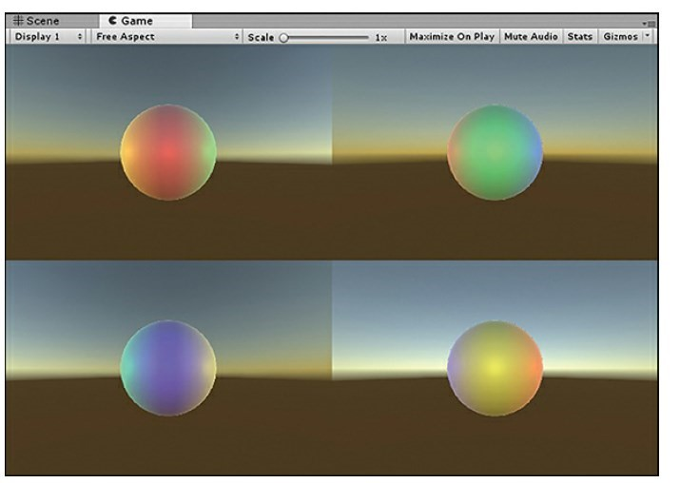

## Lights

* In Unity, we have both dynamic lighting techniques as well as light baking  
  options for better performance.
* We can add numerous light sources throughout our scenes and selectively  
  enable or disable an object's ability to cast or receive shadows. This level of  
  specificity gives us tremendous opportunity to create realistic game  
  scenes.

Activity 5.2.1: Adding a Point Light to a Scene

Follow these steps to build a scene with some dynamic point lighting:

1. **Create a new project** or scene and **delete the directional light** that is there by default (or disable it).
2. **Add a plane** to the scene (by selecting **GameObject > 3D Object > Plane**). Ensure that the plane is positioned at **(0, 0.5, 0)** and rotated to **(270, 0, 0).** The plane should be visible to the camera, but only from one side in the Scene view.
3. **Add two cubes** to the scene. Position them at **(-1.5, 1, -5)** and **(1.5, 1, -5).**
4. **Add a point light** to the scene (by selecting **GameObject > Light > Point Light**). Position the point light at **(0, 1, -7).** Notice how the light illuminatesthe inner sides of the cubes and the background plane (see Figure below).
5. Set the light’s shadow type to **Hard Shadows** and try moving it around. Continue exploring the light properties. Be sure to experiment with the light color, range, and intensity.

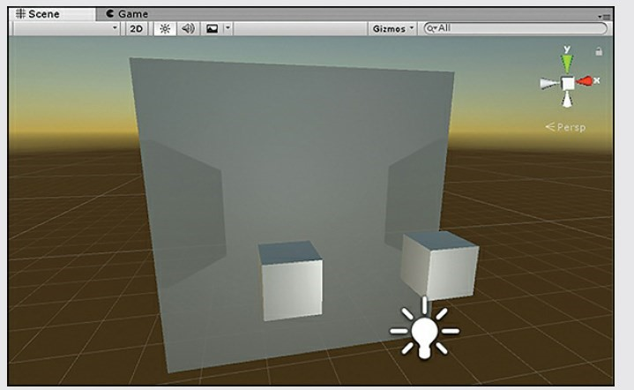

Activity 5.2.2: Adding a Spotlight to a Scene

This exercise uses the project created in the previous activity for point lights.

Continue with the following steps:

1. **Duplicate the Point Light scene** from the previous project (by selecting Edit > Duplicate) and name the new scene Spotlight.
2. Right-click Point light in the Hierarchy view and select Rename. **Rename the object Spotlight**. In the Inspector, **change the Type property to Spot**.

Position the light object at **(0, 1, -13)**.

1. Experiment with the properties of the spotlight. Notice how the **range, intensity, and spot angle shape** and change the effect of the light.

Activity 5.2.3: Adding a Directional Light to a Scene

You will now add a directional light to a Unity scene. Once again, this exercise builds on the project created in the previous activity. Follow these steps:

1. Duplicate the Spotlight scene from the previous project (by selecting **Edit > Duplicate**) and name the new scene **Directional Light**.
2. Right-click **Spotlight** in the Hierarchy view and select **Rename**. Rename the object **Directional Light**. In the Inspector, change the Type property to **Directional**.
3. Change the light’s **rotation to (75, 0, 0).** Notice how the sky changes when you rotate the light. This is due to the scene using a procedural skybox.
4. Notice how the light looks on the objects in the scene. Now change the **light’s position to (50, 50, 50).** Notice that the light does not change. Because the directional light is in parallel lines, the position of the light does not matter. Only the rotation of a directional light matters.
5. Experiment with the properties of the directional light. There is no range (because range is infinite), but notice **how the color and intensity affect** the scene.

Activity 5.2.4: Area Lights and Emissive Materials: Creating Lights Out of Objects

To add a light to an object:

**First select the object.** Then, in the Inspector view, **click the Add Component button.** A new list should pop up. **Select Rendering and then Light**. Now your object has a light component. An alternative way to add a light to an object is to select the object and select Component > Rendering > Light.

Note a couple things about adding lights to objects. First, an object will not block the light. This means that putting a light inside a cube will not stop the light from radiating. Second, adding a light to an object does not make it glow. The object itself will not look like it is giving off light, but it is.

Make one cube emits a light (using the material).

Activity 5.2.5: Halos (send to moodle)

Halos are glowing circles that appear around lights in foggy or cloudy conditions (see Figure below). They occur because light is bouncing off small particles all around the light source. In Unity, you can easily add halos to lights. **Each light has a Draw Halo check box**. If it is checked, a halo is drawn for the light. If you can’t see the halo, you may be too close to the light, so try backing up a bit.

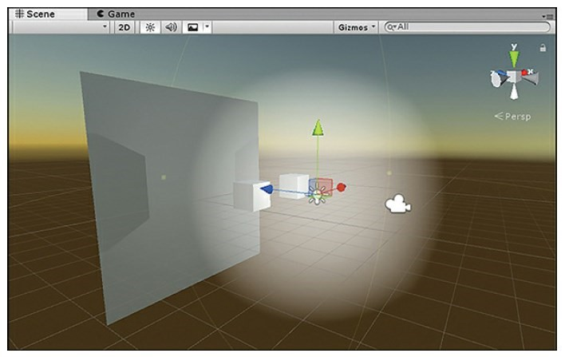

A halo around a light.

The size of a halo is determined by the light’s range. The bigger the range, the bigger the halo. Unity also provides a few properties that apply to all halos in a scene. You can access these properties by selecting **Window > Lighting > Settings. Expand Other Settings**, and the settings then appear in the Inspector view (see Figure below).

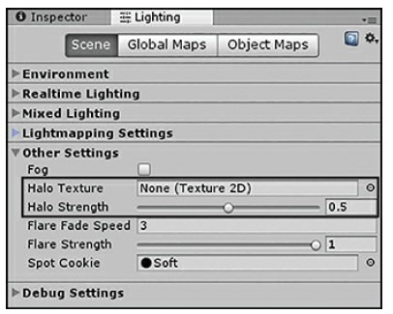

The scene lighting settings.

The **Halo Strength** property determines how big the halo will be, based on the light’s range. For instance, if a light has a range of 10 and a strength of 1, the halo will extend out all 10 units. If the strength is .5, the halo extends out only 5 units (10 × .5 = 5). The **Halo Texture** property allows you to specify a different shape for a halo by providing a new texture. If you do not want to use a custom texture for a halo, you can leave it blank, and the default circular one is used.

**Try to add a light with a halo, try to change the halo strength, notice the differences.**

Activity 5.2.6: Adding a Cookie to a Spotlight (Send To Moodle)

This exercise requires the biohazard.png image. Follow these steps to add a cookie to a spotlight:

1. Create a new project or scene. **Delete the directional light** from the scene.
2. **Add a plane** to the scene and position it at **(0, 1, 0)** with a rotation of **(270, 0, 0). 3. Add a spotlight** to the Main Camera by selecting **Main Camera** and then clicking **Component > Rendering > Light** and changing the type to **Spot**. Set the range to **18**, the spot angle to **40**, and the intensity to **3**.
3. Drag the biohazard.png texture from the book assets into your Project view. Select the texture, and in the Inspector view, change the texture type to **Cookie**, set the light type to **Spotlight**, and set the alpha source to **From** **Grayscale**. This makes the cookie block light where it’s black.
4. With the Main Camera selected, click and drag the biohazard texture into the Cookie property of the light component. You should see the biohazard symbol projected onto the plane (see Figure below).
5. Experiment with different ranges and intensities of the light. Rotate the plane and see how the symbol warps and distorts.

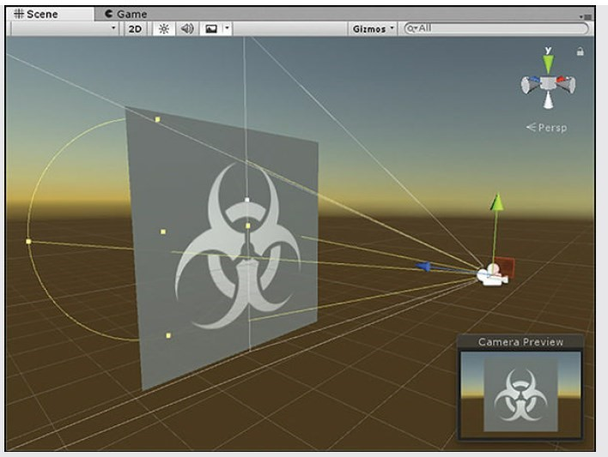

Use this image:



## Prefabs

Activity 5.3.1: Prefabs

Create a prefab to hold our sphere (created in activity 2 with red material).

Follow these steps:

1. In the Project panel, select the **Prefabs folder**.
2. Right-click on the Prefabs folder and select **Create -> Prefab**. Alternatively, you could have selected, from the top menu, Assets -> Create -> Prefab.
3. **Name the prefab “bloodDroplet**”. You will notice that there are no components or properties visible in the Inspector panel for the new prefab.
4. Next, **drag the Sphere GameObject from the Hierarchy panel to the new bloodDroplet prefab in the Project panel**. Now, when you view the prefab in the Inspector panel, you can see the components and properties that our sphere had.
5. We no longer need the original sphere, so **delete that** in the Hierarchy panel.

Now that we have a bloodDroplet prefab, we can drag it into our scene as many times as we want. We can also add them to our scene using scripts.

To experience the power of prefabs in Unity, try the following:

1. **Select the bloodDroplet prefab** in the Project panel.
2. **Drag several copies** of the bloodDroplet prefab into your scene.
3. In the Inspector panel, **change the color**. You will notice that all the bloodDroplets in your scene were changed based on the change you made to the prefab.
4. Return the color of the prefab to the red material.
5. Delete any bloodDroplets from your scene. This is most easily done in the Hierarchy panel.

Note: Deleting the bloodDroplets from your scene does not remove all bloodDroplets from your game. Because we have the bloodDroplet prefab, we can add bloodDroplets to our scene at any time

## Layers

Activity 5.4.1: Layers

**Ignoring Lights and Cameras**

Follow these steps to briefly work with layers for both lights and cameras:

1. Create a new project or scene. **Add two cubes** to the scene and position them at **(2, 1, -5)** and **(2, 1, -5).**
2. Enter the Tags & Layers Manager using any of the three methods listed earlier and **add two new layers**: Ignore Lights and Ignore Cameras.
3. Select one of the **cubes and add it to the Ignore Lights layer**. Select the other **cube and add it to the Ignore Cameras layer**.
4. Select the Directional Light in the scene, and in **its Culling Mask property, deselect the Ignore Lights layer**. Notice that now only one of the cubes is illuminated. The other one has been ignored because of its layer.
5. Select the **Main Camera and remove the Ignore Cameras layer from its Culling Mask property**. Run the scene and notice that only one nonilluminated cube appears. The other one has been ignored by the camera.

## Terrains

Activity 5.5.1: Creating a Terrain

1. Open Unity and create a new project. It will contain a Directional Light by default.
2. From the main menu, select **GameObject > 3D Object > Terrain**. A large flat plane will appear in the scene.
3. To sculpt the terrain, select the terrain in the Hierarchy. A toolset will appear in the Inspector. The operation of the buttons is defined in the table below.
4. **For sculpting, select Tool 1**. The **brush size** will affect the area of ground you can sculpt in one stroke, and **the opacity and the strength**. A higher opacity will cause more of the terrain to be lifted in one stroke.
5. **Hold down the left mouse button** over the terrain and start lifting the surface. At this state, begin with a basic outline of the lake area, as shown in the Figure below. To lower the terrain, **hold down the shift key with the mouse stroke.**
6. Using a **combination of Tools 1, 2 and 3**, sculpt and smooth the terrain into an approximate representation of the Mt. Fuji landscape as shown in last figure below.

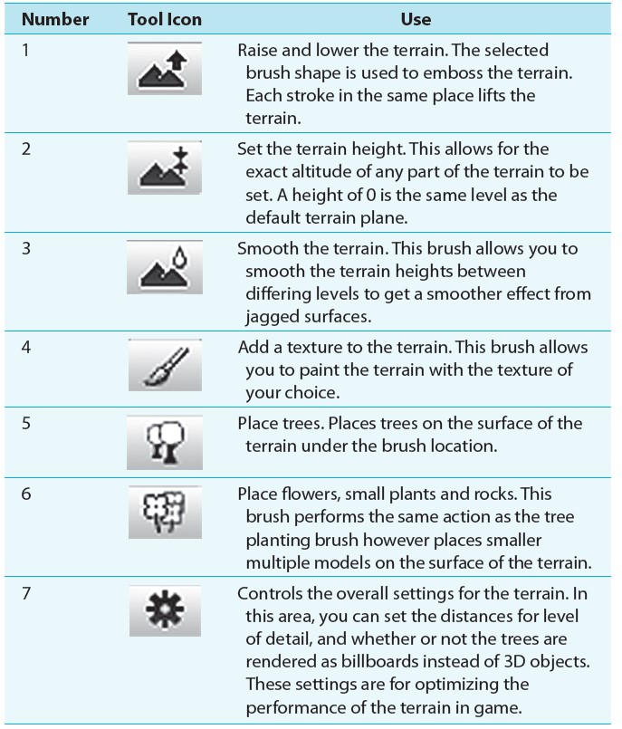

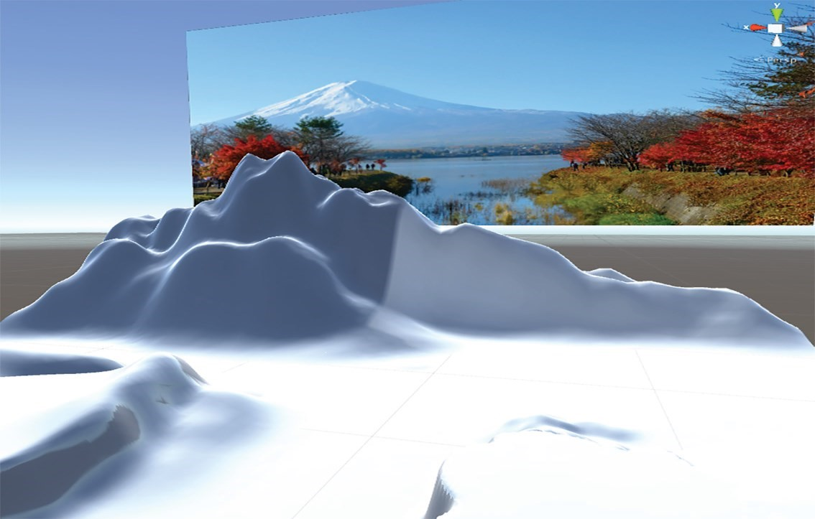

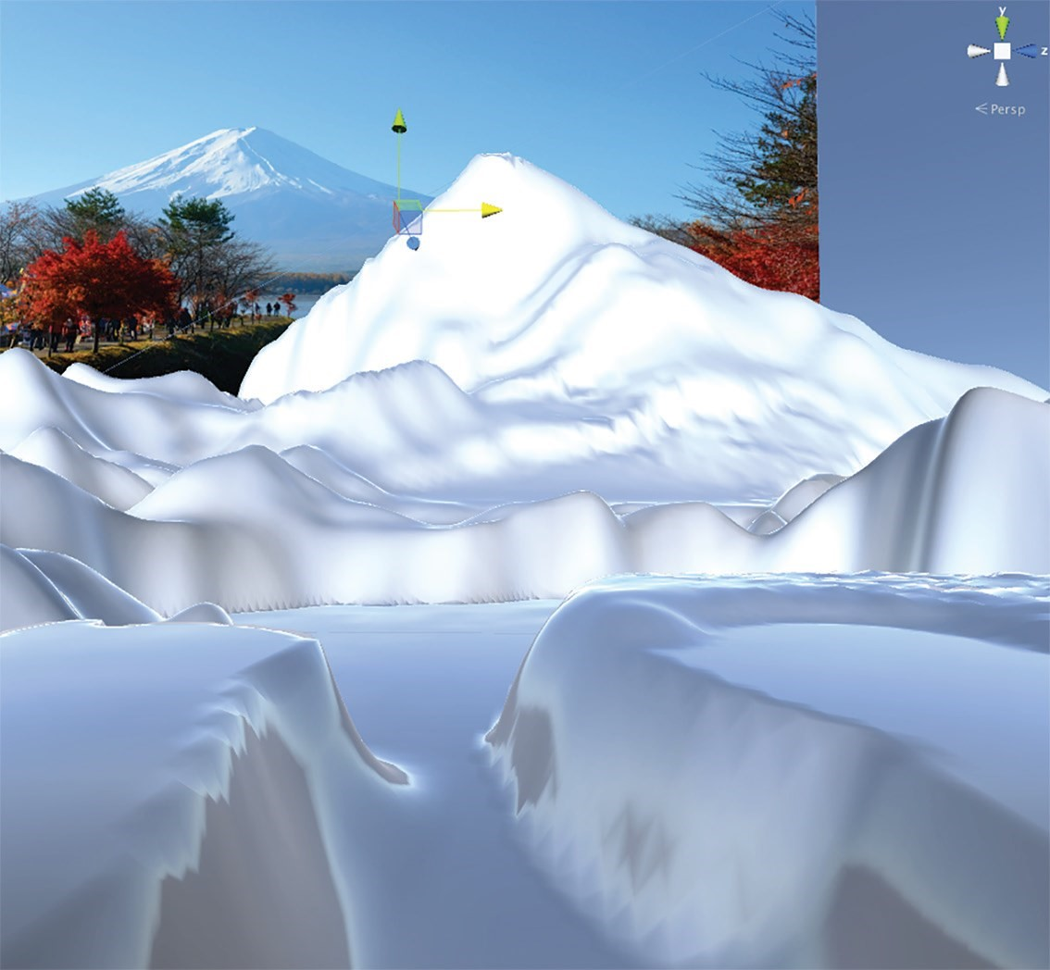

***Texturing:***

1. The terrain can be textured. For the texturing, seamless images are required. **These images must be placed in the Project**. Acquire these textures by searching on online. An excellent seamless texture pack is available at [http://www.holistic3d.com/resources/.](http://www.holistic3d.com/resources/)

**Import the standard environment package.**

1. Click on **Tool 4 to select the terrain painting brush**. Before you can start coloring the terrain, the images need to be loaded as terrain textures. **Select the Edit Textures** button as shown in the Figure below and **select Add Texture**. A popup window will allow you to **select the image** and its tile size. The larger the tile size, the more terrain a single copy of the image will cover.
2. **Select a texture** to be the first and **click on Apply** to add it to the terrain texture list. The first texture added will automatically cover the entire terrain therefore picking an image that represents the most common surface color saves a lot of texturing work later.
3. **Add more images to the texture list**, and **use the brush size, opacity and target strength settings to paint the terrain**. The opacity value sets how much of the underneath texture mixes with the newly added texture, and the target strength is how much of the added texture is placed on the surface. A low opacity will allow a lot of the underneath color to show through. A low target strength will add very little of the current texture to the surface. Experiment with these values to get the effect right. If you make a mistake, it is simple enough to recolor over the mistakes.

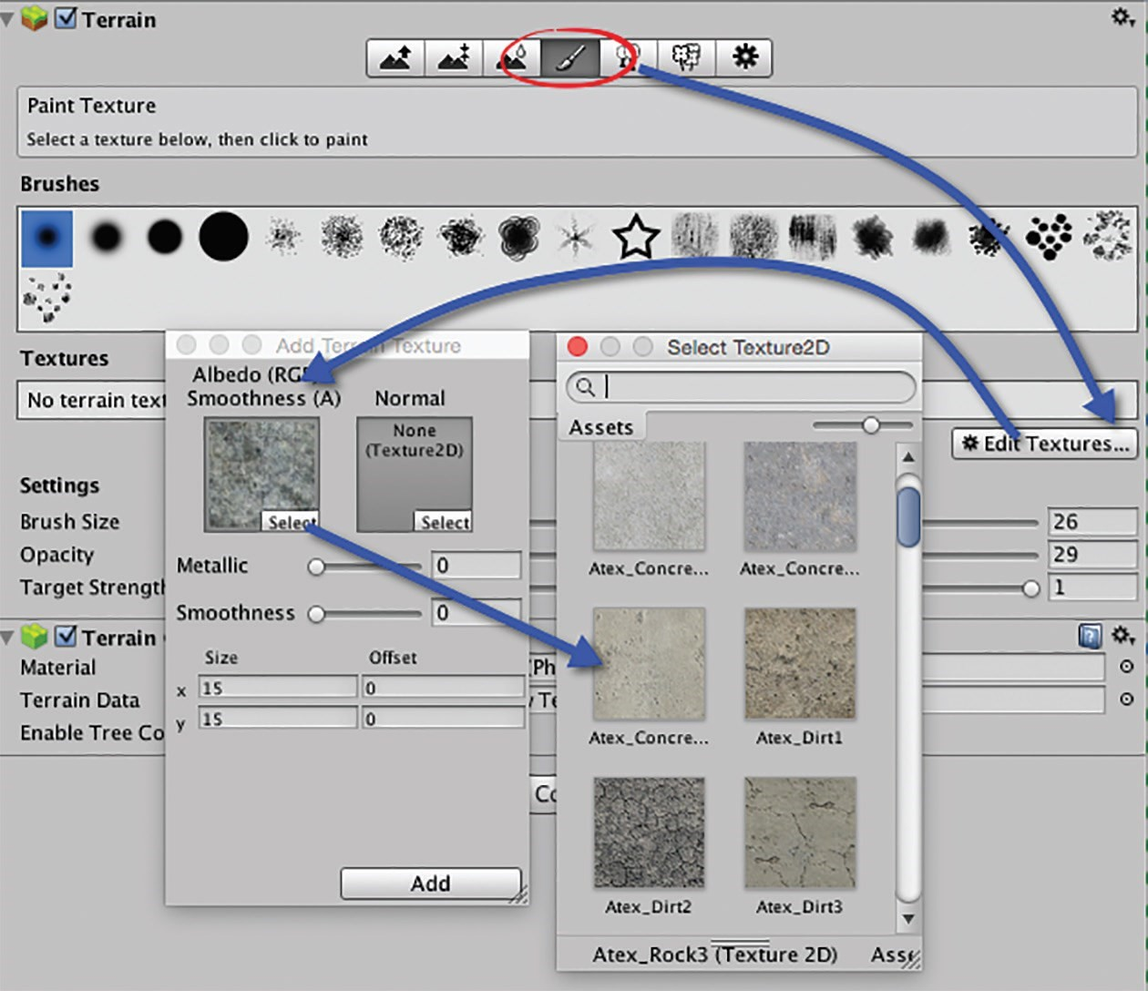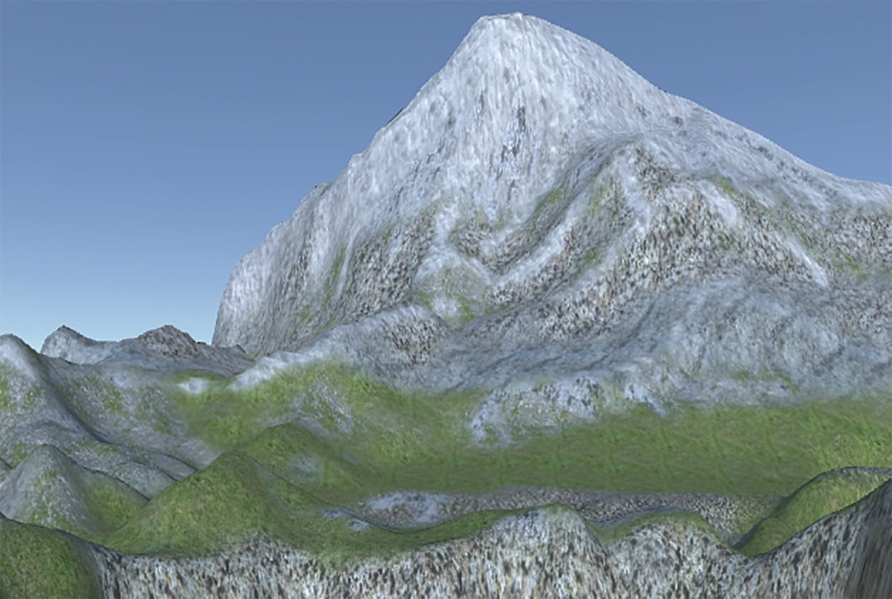

***Trees:***

Added On Unity 2019 :

1. Add Tree prefab, look on it from unity store

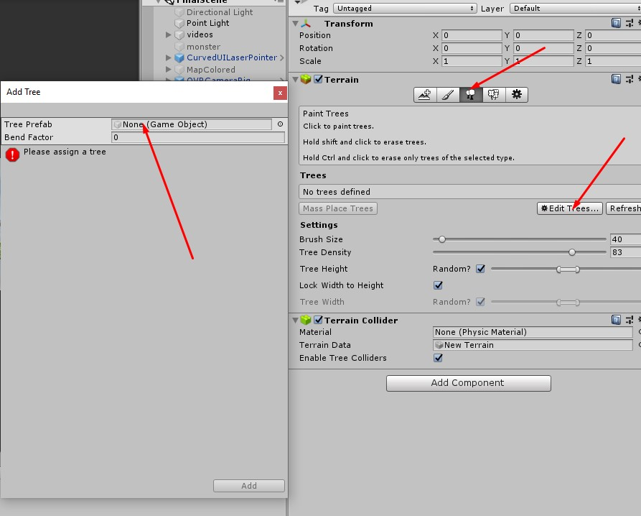

Older Unity:

Wherever trees will be placed, think about the final effect. If you want the trees to look like lush and forest, a ground color similar to the tree will make it to look denser than it is. An example of the painted terrain is shown in the Figure below.

1. Trees can also be painted onto the surface **using Tool 5**. Currently there will be no trees in the Project. **Download the free Terrain Assets by Unity Technologies package** available in the Asset store and **import into your project.**
2. Trees are added to the tree brush in **the same way as images** are added to the textures. **Add a couple of appropriate trees**.
3. Examine the photograph of Mt. Fuji. Notice how the trees do not cover the entire landscape? Obviously they will not be in the lake area but they are thickest near the water and thin out to a distinct level after which the odd tree is found. In the real world, elevation and soil content at heights make it inhospitable for trees. Therefore mimicking nature in this way makes the terrain look better.
4. In the picture of Mt. Fuji, there is also a line of reeds and grass around the edge of the lake. Grass and flowers can be added with Tool 6. They are painted in the same way as Trees. Once you have added the trees, take a small texture painting brush, **select a grass or flower**, and add this detail. It will lift the tree line and create a break between water and land.
5. Adjust the wind properties to affect the grass.

**Water and trees wind (home work)**

1. To add water, **C**. Once imported, search in the Standard Assets folder in the Project for the **Water4**Advanced prefab. **Drag and drop this into the Scene.** Resize and reposition such that it wills the lake area in front of the mountain.
2. Add a wind zone to affect the trees in the scene.

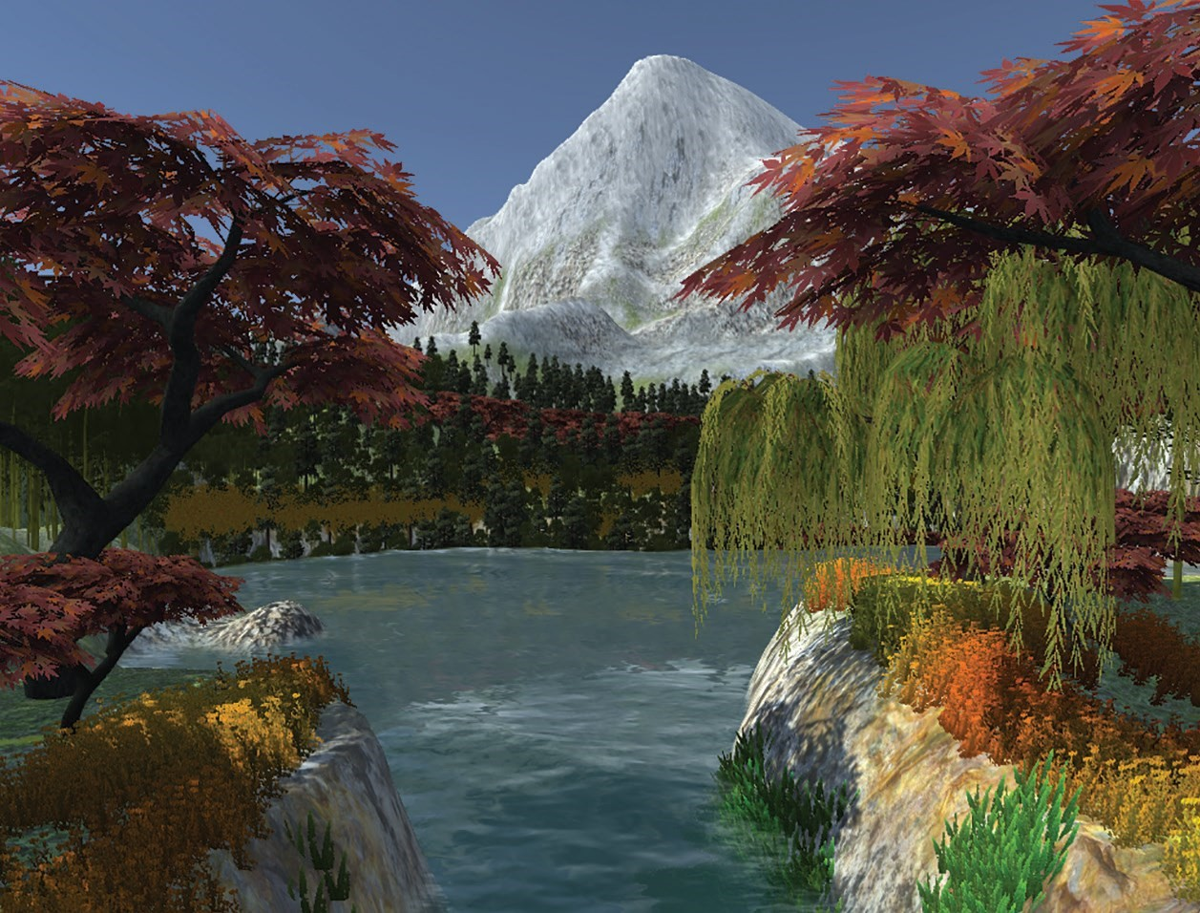

Activity 5.5.2: Terrain Continued (FBC and Web version)

For the Terrain scene you did do the following:

1- Add a FPC controller to your scene so that the players can navigate all the terrain: you can import it as an asset from asset store or other sites.

2- Build your scene to Web gl format to make it available online: You can use this website or other: https://simmer.io/

Submit the following:

The game package

The online game URL

# Physics and UI

Physics simulation is a vital component for creating immersive and realistic gameplay experiences. In Unity, you have access to a powerful physics engine that enables you to bring objects to life with dynamic interactions and realistic behaviors. This introduction will explore essential concepts such as rigid bodies, colliders, physics materials, and triggers.

**Rigid bodies** serve as the building blocks of physical objects within your game world. They define the mass, velocity, and rotational properties of objects, allowing them to move and interact under the influence of physics forces. By applying forces or impulses, you can make objects respond realistically to gravity, collisions, and user inputs, providing a sense of weight and dynamics.

**Colliders** play a fundamental role in defining the shape and boundaries of objects for collision detection. Unity offers a wide range of collider types, including spheres, boxes, capsules, and meshes, allowing you to accurately represent the geometry of your game objects. By assigning colliders to your rigid bodies, you enable them to detect and respond to collisions with other objects, triggering appropriate reactions and physics-based behaviors.

**Physics materials** come into play when determining how objects interact with each other. By assigning physics materials to colliders, you can control properties such as friction and bounciness, influencing the way objects slide, roll, or bounce off surfaces. This allows you to fine-tune the physical behavior of your game objects, ensuring that they behave realistically and convincingly within the game environment.

**Triggers** provide a mechanism for detecting specific events or interactions in your game. Unlike regular colliders, triggers do not physically affect other objects but instead act as detectors. By attaching trigger colliders to objects or specific areas within your scene, you can define trigger events that are activated when other objects enter or exit the trigger area. This opens up possibilities for implementing gameplay mechanics, such as detecting when a player reaches a certain area, activating power-ups, or triggering scripted events.

Activity 6.1: Start Physics

Add a Plane, a Cube in the center of the plan (above it).

Part 1- Add a rigid body to the cube so that when plays it fail on the ground.

Part 2 - Each time the player clicks on space the cube will be pushed (above or forward).

Part 3 - Add a wall in front of the cube, when the cube hits the wall, a message is displayed "you hit the wall"

Part 4 - Add a function reset that return the cube to its initial position when the player click on R.

Activity 6.2: Wall Breaker

In this activity, we will use a cannon ball to break the walls.

**Objectives:**

1. Learn some basics of scripting and instantiating prefabs.
2. Learn some basics of physics.

**Let’s start!**

1. Create a new project, and a new scene, name it WallBreaker.

1. open the Scene and create a plane, reposition it as follows:

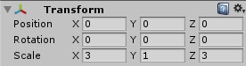

1. Create an empty gameObject rename it as Camera, drag and drop the MainCamera into it.



1. Go to the MainCamera, change its position as follows:

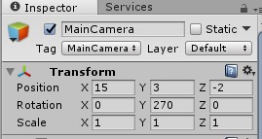

1. Now, let’s start with the Bricks wall.

First, go to the Assets folder and create two folders, one for the Scripts, the other one name it as Prefabs, we will talk about it later on!

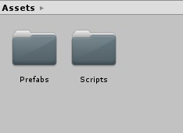

Go to the Hierarchy, create a 3d cube name it as ‘PhysicsPowerCube’, from the Inspector click Add Component button then add a box collider, click it again and add a Rigiddody. Change its scale as follows:

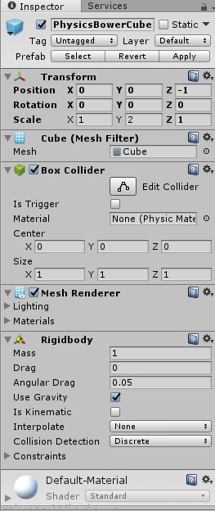

1. Drag the PhysicsPowerCube and drop it at the Prefabs folder to make it as a prefab.

By making this, whenever you duplicate a prefab, the duplicated version will have the same components and properties of its prefab. Notice its color in the Hierarchy changed to blue.

1. Duplicate our PhysicsPowerCube, and move it exactly one unit to make a row as follows:

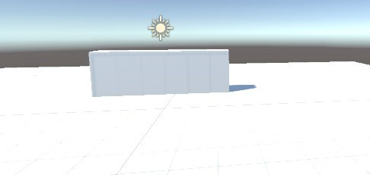

How we can move the duplicated cube exactly one unit without making unnecessary spaces between the cubes??

1. create an empty GameObject, name it as ‘row’, then move all the duplicated cubes inside it.

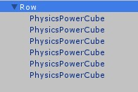

1. Duplicate the Row to make two other rows as follow:

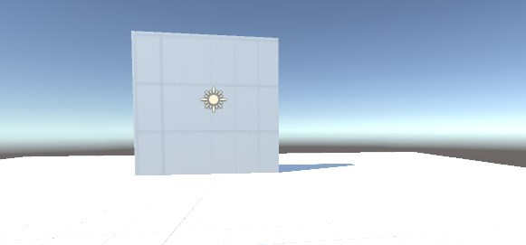

1. Create a Sphere, name it as ball. Click add component button from the Inspector and add a Rigidbody and a Sphere Collider.

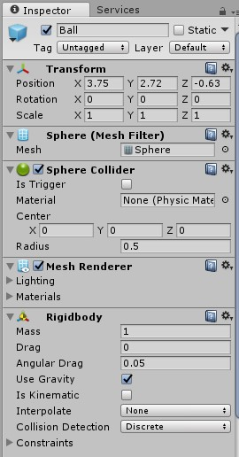

1. Drag and drop it in the Prefabs folder to make it as a prefab, then delete the ball from the Hierarchy as we don’t need it right now, we will use it later on!

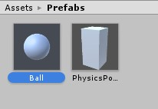

1. Let’s go back to our Camera, we will going to have a First Person view, so we will put the Wall breaker script on the camera!

Click on the camera, then click on add Component button, add a c# script and name it as ‘WallBreaker’.

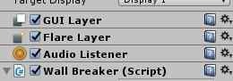

1. Click on the script to open it, and start writing the code:
   * Let’s define some public variables, we will assign them later on but let’s define them as follows:
   * 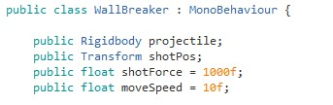
   * Now, let’s use a new way dealing with the user Keyboard Input instead of defining the exact keyboard buttons, by using Horizontal and Vertical, this will allows you to use the 4 arrow buttons as well as (W,A,S,D) to move through the 4 directions!
   * 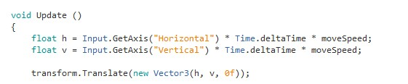
   * The same thing for the Mouse Input, all this, are predefined buttons in the InputManager, such as Horizontal and Vertical, Get Button will return to false when it is released.

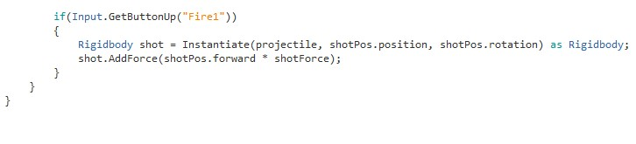

1. Save the Script, and return back to Unity.

1. Create an empty GameObject to be the position where our projectile will be shot from. Name it as ShotPos, drag and drop it under our camera.

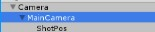

1. Click on the small gear button to reset the position of the ShotPos gameObject then change its position and scale as follows:

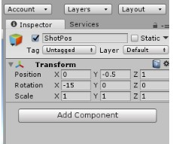

1. Now, click on the MainCamera gameObject, go to the script component, drag and drop the ball prefab in the Projectile field, then add the ShotPos gameObject in the ShotPos field as follows:

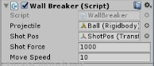

1. Hit the play button and enjoy breaking the bricks!

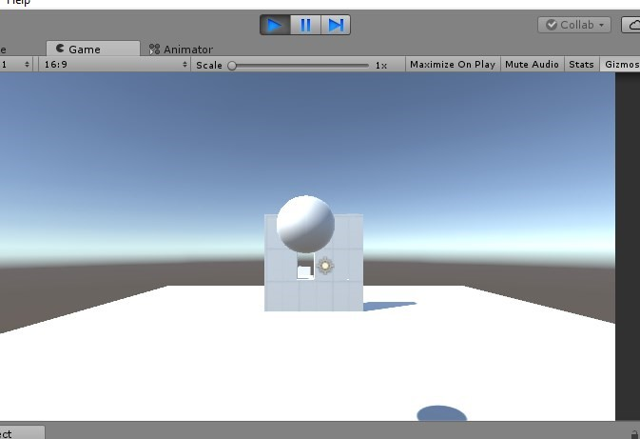

Don’t close this Assignment, we haven’t finished yet!

As you continue playing and shooting your ball, notice what is happening in the hierarchy, it’s something really annoying to keep cloning your GameObject and this will cause some problems in the game later on..



* + 1. Find a way you can reduce this clones or even get rid of them all!
    2. As we go through materials and textures in the previous activities, it’s **unfair** to deliver this assignment without colors, so add some textures and materials :]

Good Luck :) !

Activity 6.2: UI

Please do the following tasks:

Make a splash screen (Background image + a button "Play")

Add a new scene (StartScene) where you should add a button "Show Score" and a text that displays the score, When the player clicks on the button "Show Score" the text displays the score (Constant number).

Add a button called "Play" to th splash screen, when the player clicks this button the start scene is shown.

Add a text on the HMD that displays the value of score "example the score is 100".

Display the time (in seconds).

Activity 6.3: Bowling - Assignment

In this activity, we will make a bowling stage and a throughable ball.

**Part 1: Create the scene – Physical properities**

1. Create a new project called **Physical Engine**
2. Save the scene as **Bowling**
   * + Create a plane of dimensions (0.5, 1, 5) in (0, 0, 24), rename it **Parquet**, apply to it the **Texture_parquet** and, in the **Material** created, make a **Tiling** of 5 in Y
     + Create a sphere in (0, 0.5, 0), rename it **Ball** and apply the **Texture_ball**
     + Position the camera so that it is behind the ball, overlooks the stage and allows to see the track until the end.
     + Add a Rigidbody to the ball and put it in **Is Kinematic** ➢ Create a new script called **Launch** and apply it to the ball.
3. Code the following interactions:
   * + - * When the player presses the Spacebar ...
         * The duration of pressing the key is calculated
         * The duration of the click is an elapsed time (to measure the present time, use the **Time.time** value)
         * This time elapses between the moment when the key is pressed, and the moment when it is released (class **Input**, methods ...) ➢ This duration is multiplied to a force (**Vector3 force = Vector3.forward * 1000**). On which component of the vector is the multiplication?
         * The ball is no longer **isKinematic**
         * The force is applied to the ball: **Rigidbody.AddForce(Vector3 force)**

**Part 2: More Methods, triggers**

* 1. When the player presses the R key (to Restart) ...
  2. When the player presses one of the arrows right / left
     + - The duration of pressing the key is calculated
       - We add / subtract the duration of click * 100 to one of the components of the force vector. Which ?
       - As long as the key remains pressed, the ball is rotated to the right or left to give a visual indication so that the player knows in which direction he is aiming. The rotation **Vector3** is (**Vector3.up / 5f**)
  3. Edit the Launch script so that if the ball touches one of the gutters, a message "Gutter! No, but frankly! »Be sent in console
  4. Edit the **Launch** script so that, if the ball has finished crossing this large region **Restart**, then the bowling is fully reset, as when pressing the R key. **Part 3: Create the UI – splash screen**
  5. Create a new scene, which you will call **SplashScreen**
  6. It will be interesting, for this exercise, to select **Maximize on Play** and to vary the image formats under the **Game tab**
  7. Create a black flat on the whole screen to make a **background**
  8. What anchorage for this black background?
  9. Import the image for the *splash screen* and, in its import properties, indicate that it is intended to be displayed as a UI: **Texture Type> Sprite (2D and UI)**
  10. Create a background with the imported image. Be careful, it must cover as much screen area as possible, but must not be distorted (remember to press Shift to proportionally resize).
  11. **You can resize the canvas, by modifying the canvas Scaler (UI scale mode: scale with screen size)**
  12. Import the font for the *splash screen* Adding Text
  13. **Add a Text** element, where you will write "Bowling is FUN!” With the imported font, navy blue
  14. Center text vertically and horizontally
  15. Adjust the font size and the size of the object according to the result on the screen. The **Best Fit** check box can be your friend, if you adjust the minimum and maximum font size, below
  16. What anchoring for your text? Adding buttons
  17. **Add a carmine red button** at the bottom right (for **Normal Color**, then dim down to vermilion for **Highlighted** and **Pressed** colors). Write "Start playing! In navy blue in the same font as the title.
  18. What anchoring for this button?
  19. When the player click the button, a new scene will be loaded (level 1 scene)

Adding HMD

* 1. Add a score text at the upper left side of the game to display the score dynamically.